14.(b).String reverse.
import java.util.Scanner;
public class strrev {
public static void main(String[] args) {
String s;
int i,len=0;
System.out.println("enter a string : ");
Scanner a = new Scanner(System.in);
s=a.nextLine();
len=s.length();
for(i=len-1;i>=0;i--){
System.out.println(s.charAt(i));
}
}
}

output.
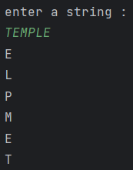

15.(a).Number palindrome
import java.util.Scanner;
public class intpalindrome {
public static void main(String[] args) {
System.out.println("enter a number : ");
Scanner num = new Scanner(System.in);
int number = num.nextInt();
int n=number;
int rev=0,temp;
while(n!=0){
temp=n%10;
rev=rev*10+temp;
n=n/10;
}
if(rev==number){
System.out.println("palindrome");
}
else{
System.out.println("not palindrome");
}
}
}

output.
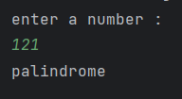

15.(b).String palindrome.

import java.util.Scanner;
public class strpalindrome {
public static void main(String[] args) {
String s;
int i,len=0;
String rev="";
System.out.println("enter a string : ");
Scanner a = new Scanner(System.in);
s=a.nextLine();
char c[]=s.toCharArray();
len=s.length();
for(i=len-1;i>=0;i--){
rev=rev+c[i];
}
if(s.equals(rev)){
System.out.println("palindrome");
}
else{
System.out.println("not palindrome");
}
}
}

output.
